**EXERCISE 1. DDL COMMANDS**

**OUTPUTS**

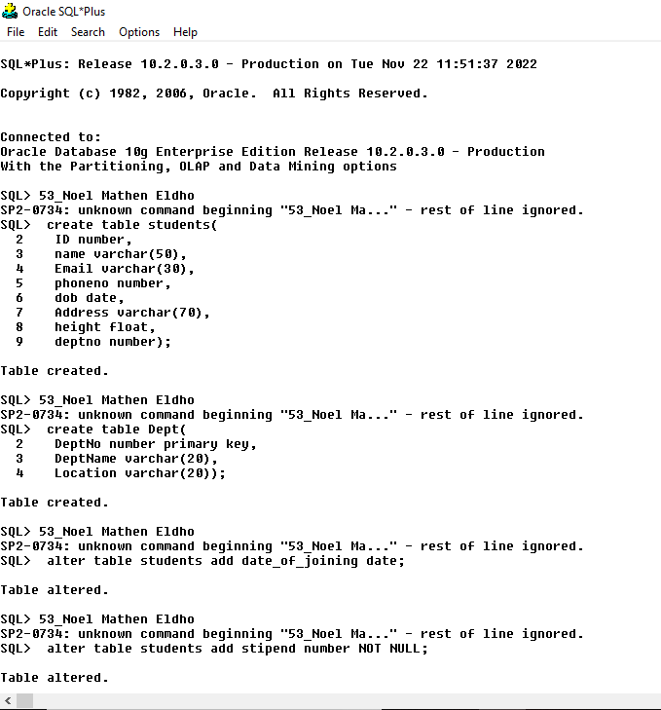

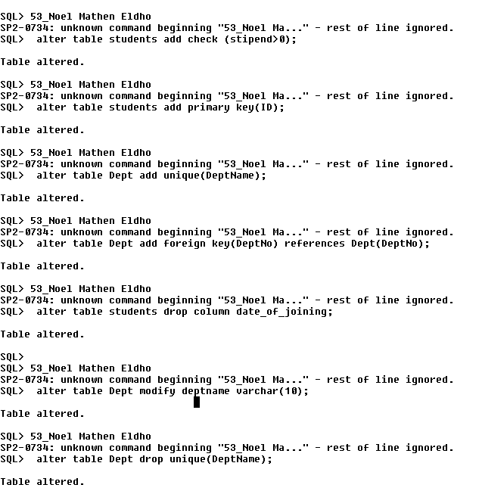

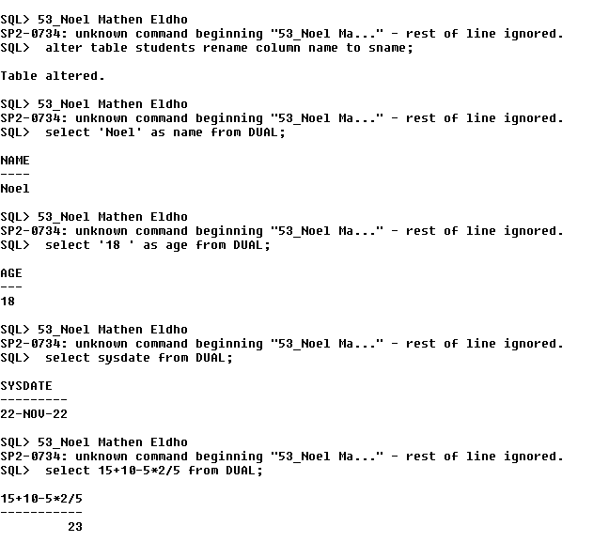

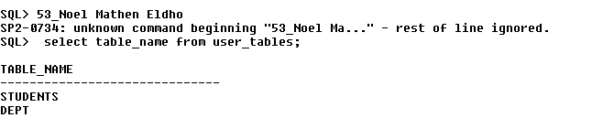

**SQL*Plus: Release 10.2.0.3.0 - Production on Tue Nov 22 10:14:46 2022**

**Copyright (c) 1982, 2006, Oracle. All Rights Reserved.**

**Connected to:**

**Oracle Database 10g Enterprise Edition Release 10.2.0.3.0 - Production**

**With the Partitioning, OLAP and Data Mining options**

**SQL> create table students(**

**2 ID number,**

**3 name varchar(50),**

**4 Email varchar(30),**

**5 phoneno number,**

**6 dob date,**

**7 Address varchar(70),**

**8 height float,**

**9 deptno number);**

**Table created.**

**SQL> create table Dept(**

**2 DeptNo number primary key,**

**3 DeptName varchar(20),**

**4 Location varchar(20));**

**Table created.**

**SQL> alter table students add date_of_joining date;**

**Table altered.**

**SQL> alter table students add stipend number NOT NULL;**

**Table altered.**

**SQL> alter table students add check (stipend>0);**

**Table altered.**

**SQL> alter table students add primary key(ID);**

**Table altered.**

**SQL> alter table Dept add unique(DeptName);**

**Table altered.**

**SQL> alter table Dept add foreign key(DeptNo) references Dept(DeptNo);**

**Table altered.**

**SQL> alter table students drop column date_of_joining;**

**Table altered.**

**SQL> alter table Dept modify deptname varchar(10);**

**Table altered.**

**SQL> alter table Dept drop unique(DeptName);**

**Table altered.**

**SQL> alter table students rename column name to sname;**

**Table altered.**

**SQL> select 'Noel' as name from DUAL;**

**NAME**

**----**

**Noel**

**SQL> select '18 ' as age from DUAL;**

**AGE**

**---**

**18**

**SQL> select sysdate from DUAL;**

**SYSDATE**

**---------**

**22-NOV-22**

**SQL> select 15+10-5*2/5 from DUAL;**

**15+10-5*2/5**

**-----------**

**23**

**SQL> select table_name from user_tables;**

**TABLE_NAME**

**------------------------------**

**STUDENTS**

**DEPT**